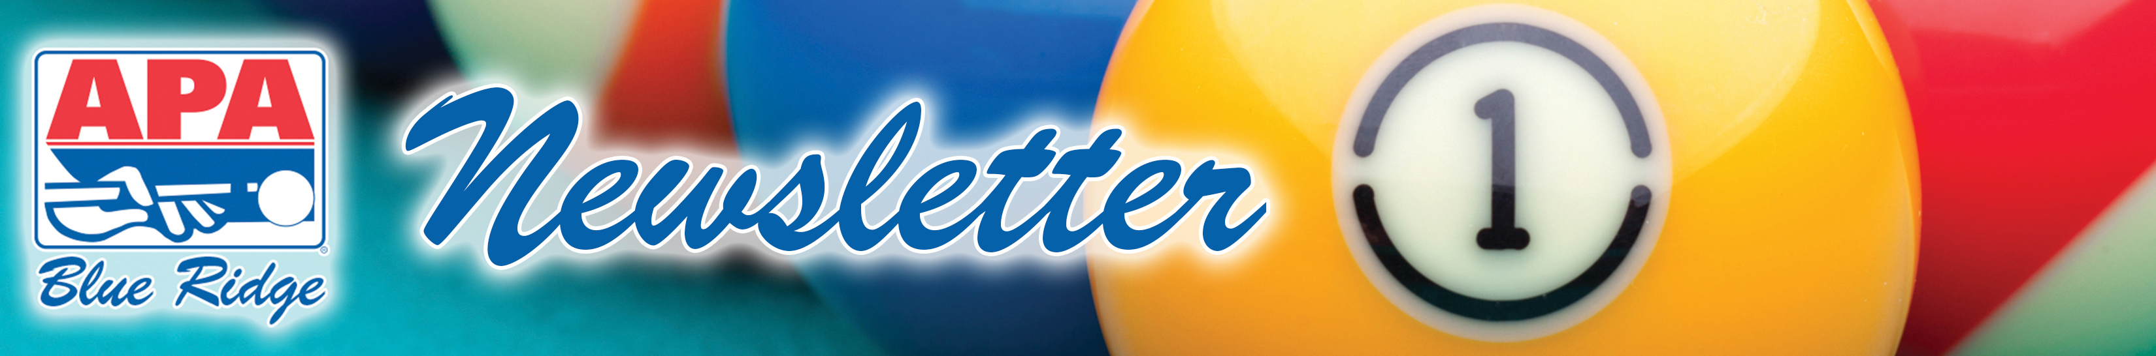

February 24, 2014: Volume XVIII – Issue 7

CUE TIP OF THE WEEK: PRO-RATED MEMBERSHIPS
All members that joined at the end of last year receive $10 off their renewal for 2014 (only $15 for the entire year instead of $25). All prorated membership offers will expire on March 1st. Make sure prorated members pay THIS week in order to take advantage of the discount.


THIS WEEK’S BOUNTY HUNT:
Hal White from “King Zach & His Princesses” – there’s a bounty on your head this week. Play and win your match this Saturday and your match is free! If his opponent (the bounty hunter) wins, then the bounty hunter plays for free!

PATCH PROGRAM NOTES
Blue Ridge APA is proud to recognize the accomplishments of its members by awarding patches for performing well during a match. Here are a few reminders:

- Rackless patches are awarded only in 8-ball. To receive a Rackless, you must win the lag and all of the games in the match. Additionally, no Rackless patch is awarded if there is a S8, E8, or WP during the match.
- Patches are not awarded if they are not marked on the scoresheet.
- If there is a make up match pending, then the patches will be awarded after the make up matches have been completed.

SWAP your patches for raffle tickets to win a free trip to Las Vegas! Just write on your scoresheet that you want to swap your patch and your raffle ticket will be entered into the drawing. Or send your old patches back to the office in your team packet with a note requesting to swap patches for raffle tickets.

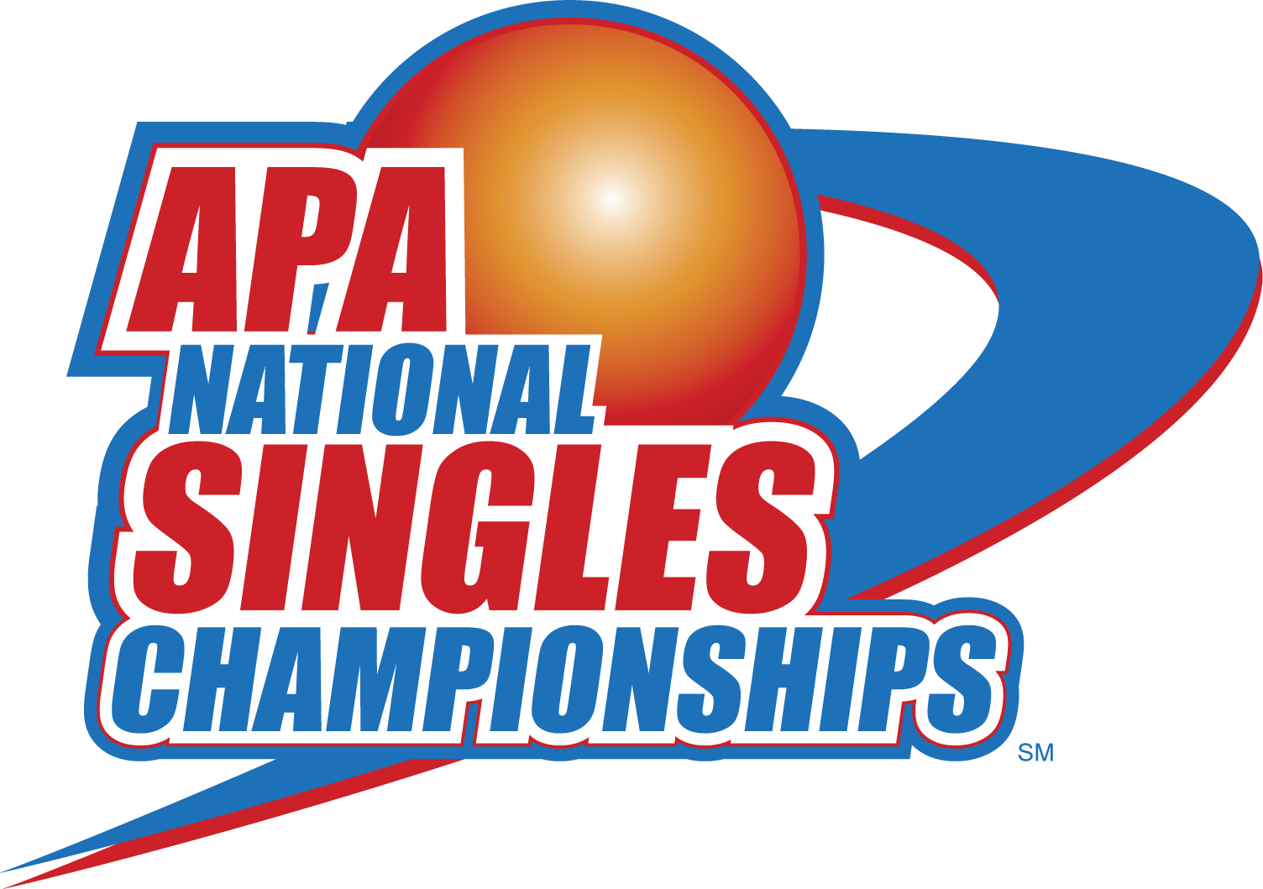
GOOD LUCK BLUE RIDGE APA! WIN A SINGLES BOARDS TO GO TO CHARLESTON!
This weekend is the spring regional tournament where individual players will compete to go to the National Team Championship in Las Vegas! Good luck to our players going to Charleston!

CITY BILLIARDS singles board every Saturday at 2:00!
